**SAMBA SHARE**

**Experiment:** 2

**Aim:** Installation and configuration of Samba share.

**Description:**

SAMBA

One of the most common ways to network Ubuntu and Windows computers is to

configure Samba as a File Server. This section covers setting up a Samba server to

share files with Windows clients.

The server will be configured to share files with any client on the network without

prompting for a password. If your environment requires stricter Access Controls see

Share Access Control

**Port No:** 139

**Package name**: samba

**Configuration file:** /etc/samba/smb.conf.

**Procedure:**

1. To install Samba, we can run:

$sudo apt update

$sudo apt install samba

2. We can check if the installation was successful by running:

$whereis samba

3.Now that Samba is installed, we need to create a directory for it to share:

$mkdir /home/&lt;username&gt;/sambashare/

The command above creates a new folder samba share in our home directory which

we will share later.The configuration file for Samba is located at

/etc/samba/smb.conf. To add the new directory as a share,we edit the file by

running:

$sudo nano /etc/samba/smb.conf

At the bottom of the file, add the following lines:

[sambashare]

comment = Samba on Ubuntu

path = /home/username/sambashare

read only = no

browsable = yes

4. Then press Ctrl-O to save and Ctrl-X to exit from the nano text editor.

5. Now that we have our new share configured, save it and restart Samba for it to

take effect:

$sudo service smbd restart

6.Update the firewall rules to allow Samba traffic:

$sudo ufw allow samba

SETTING UP USER ACCOUNTS AND CONNECTING TO SHARE

7.Since Samba doesn’t use the system account password, we need to set up a Samba

password for our user account:

$sudo smbpasswd -a username

CONNECTING TO SHARE

8. On Ubuntu: Open up the default file manager and click Connect to Server then

enter: Connecting to samba via smb://127.0.0.1/sambashare

Note: ip-address is the Samba server IP address and sambashare is the name of the

share. You’ll be prompted for your credentials. Enter them to connect!

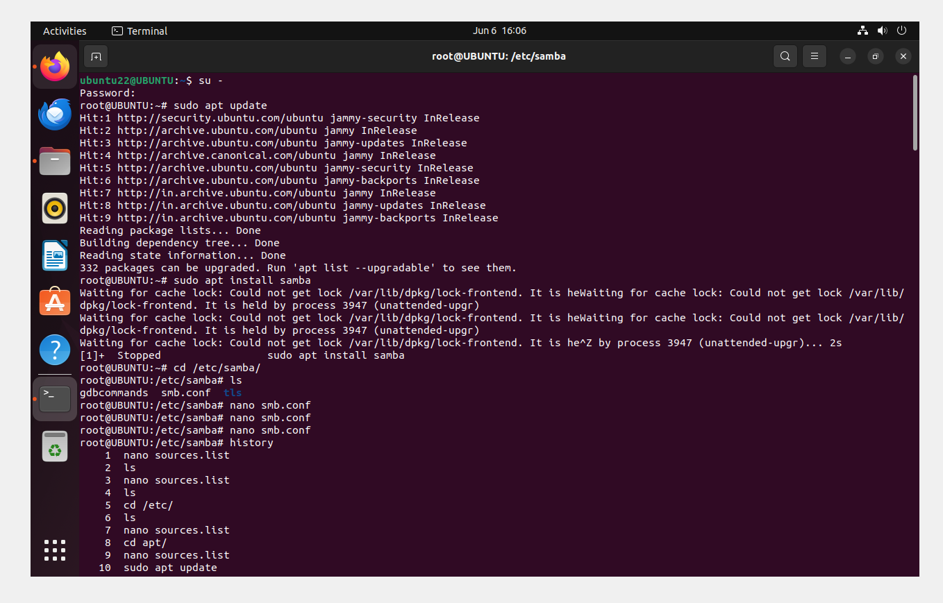

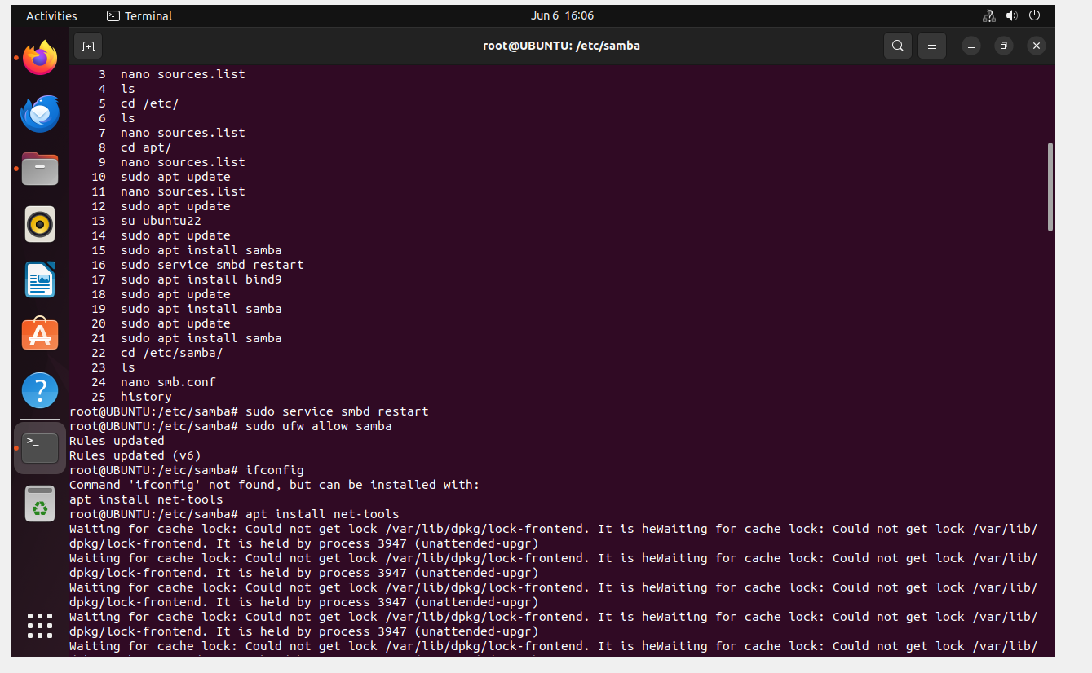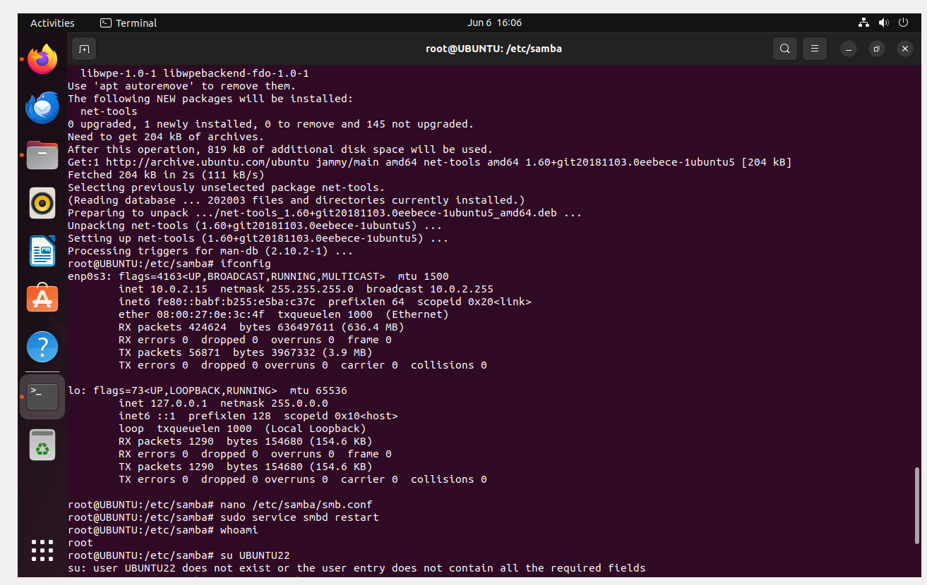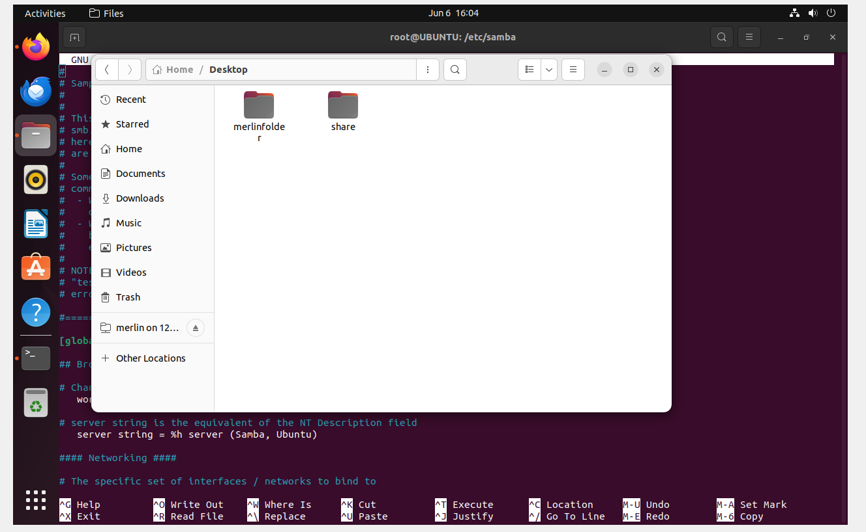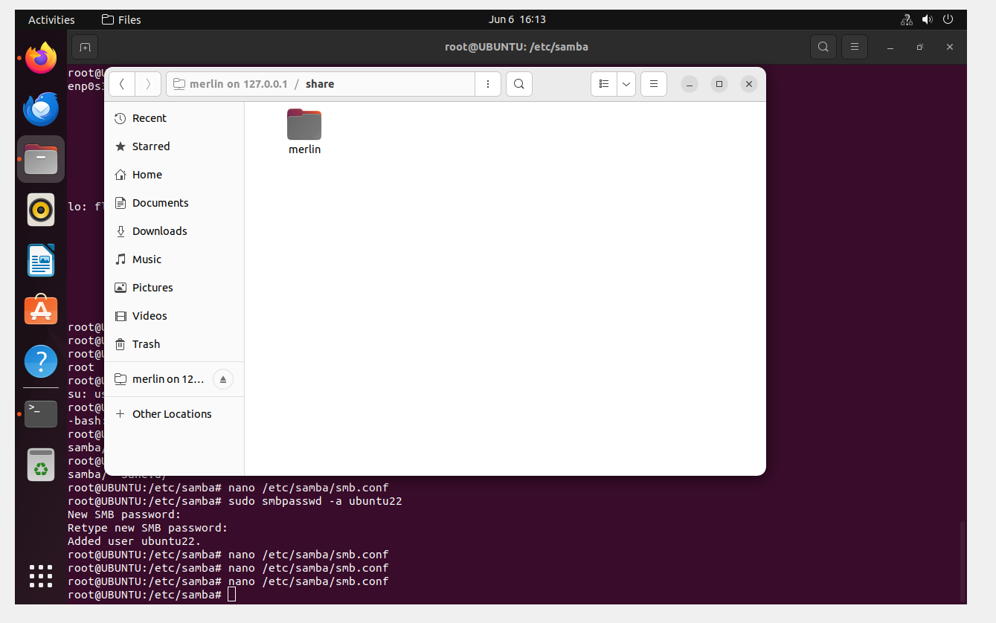

**Result:** All the commands have been executed and the output has been obtained successfully.